Name: Justin Shawn Allen

Reg No:192121111

1.CODE:

import cv2

import numpy as np

kernel = np.ones((5,5),np.uint8)

print(kernel)

path = "C:/Users/justin shawn allen/OneDrive/Pictures/WhatsApp Image 2023-07-10 at 15.15.09.jpg"

img =cv2.imread(path)

imgGray = cv2.cvtColor(img,cv2.COLOR_BGR2GRAY)

cv2.imshow("GrayScale",imgGray)

cv2.waitKey(0)

OUTPUT:

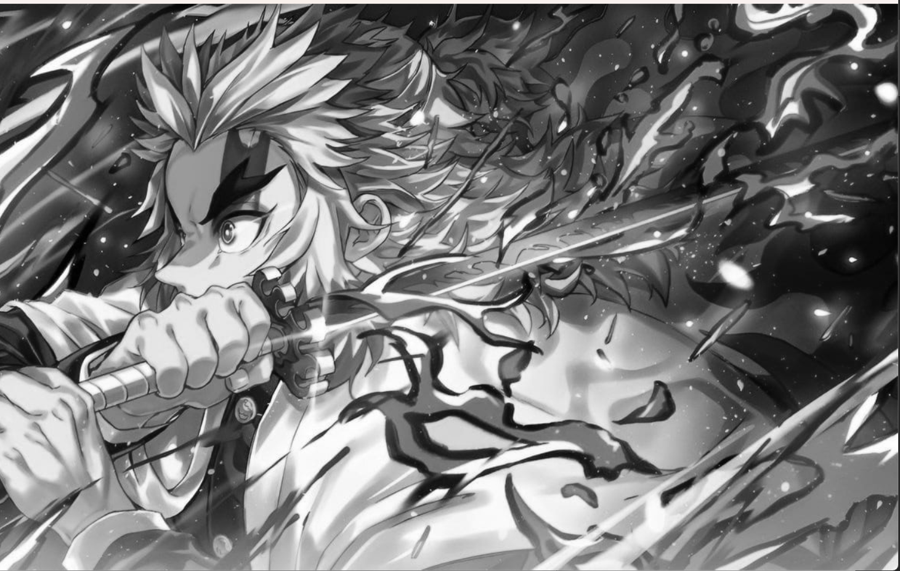

2.

import cv2

import numpy as np

kernel = np.ones((5,5),np.uint8)

print(kernel)

path = "C:/Users/justin shawn allen/OneDrive/Pictures/WhatsApp Image 2023-07-10 at 15.15.09.jpg"

img =cv2.imread(path)

imgGray = cv2.cvtColor(img,cv2.COLOR_BGR2GRAY)

imgBlur = cv2.GaussianBlur(imgGray,(7,7),0)

cv2.imshow("Img Blur",imgBlur)

cv2.waitKey(0)

Output:

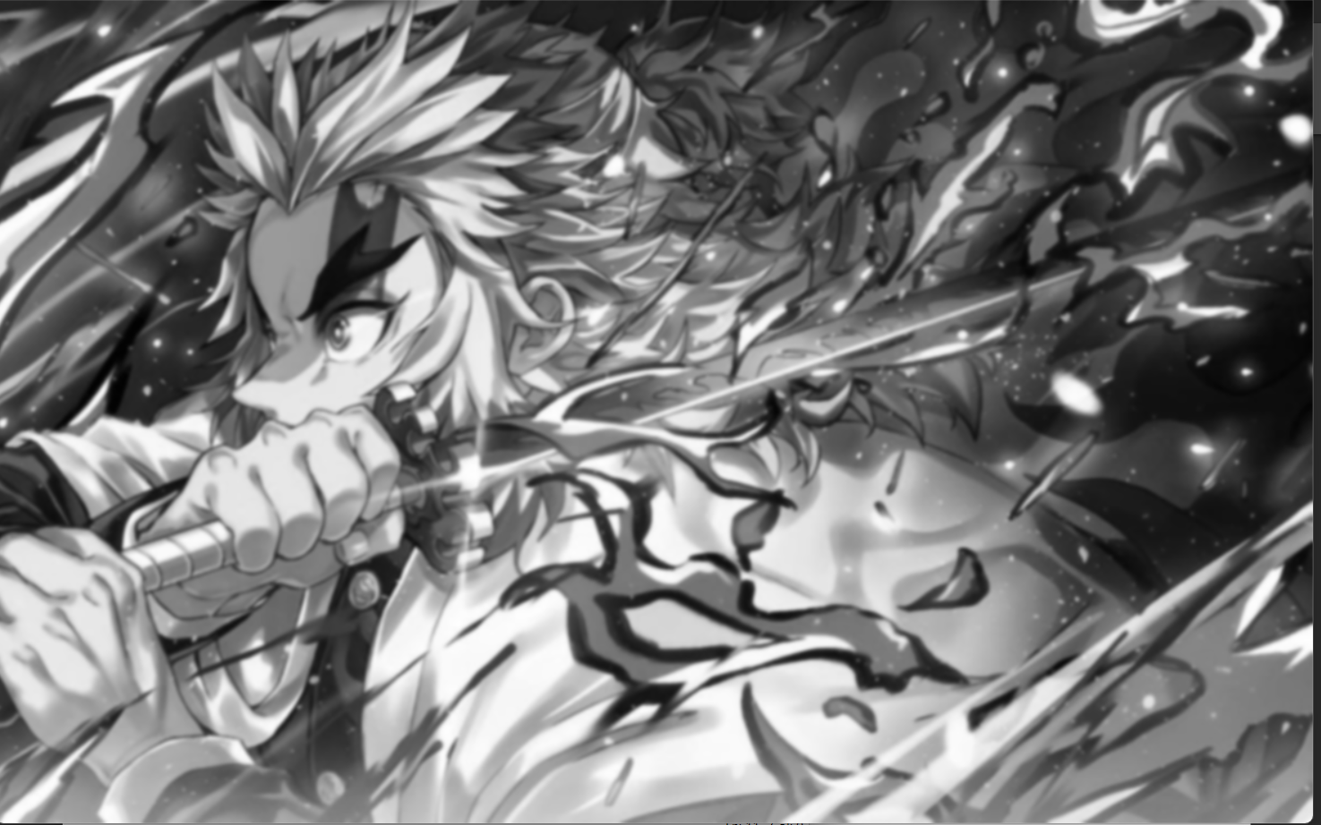

3.

import cv2

import numpy as np

kernel = np.ones((5,5),np.uint8)

print(kernel)

path = "C:/Users/justin shawn allen/OneDrive/Pictures/WhatsApp Image 2023-07-10 at 15.15.09.jpg"

img =cv2.imread(path)

imgGray = cv2.cvtColor(img,cv2.COLOR_BGR2GRAY)

imgBlur = cv2.GaussianBlur(imgGray,(7,7),0)

imgCanny = cv2.Canny(imgBlur,100,200)

cv2.imshow("Img Canny",imgCanny)

cv2.waitKey(0)

O/P.

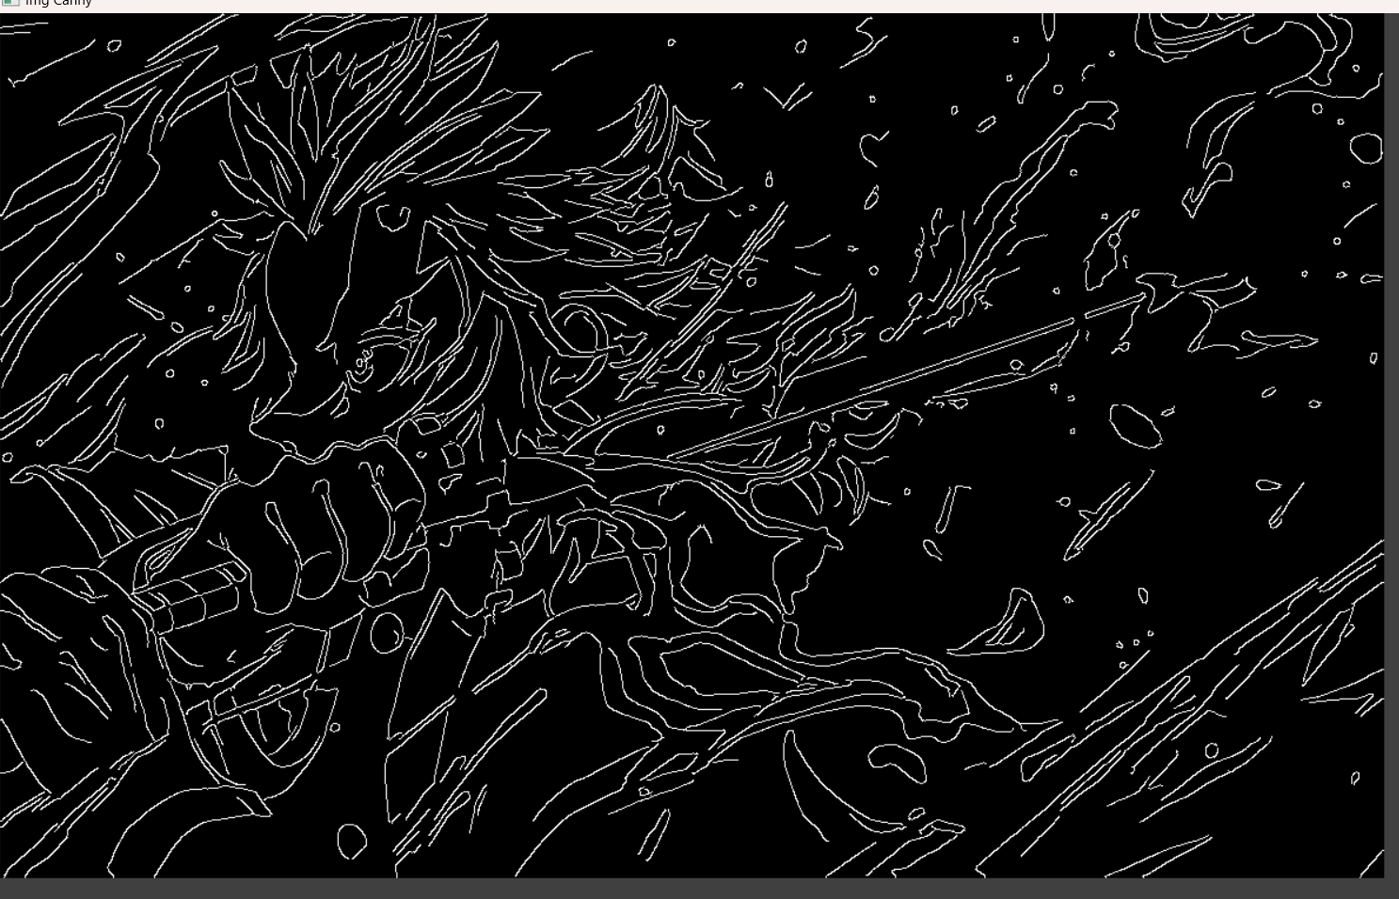

4. import cv2

import numpy as np

kernel = np.ones((5,5),np.uint8)

print(kernel)

path = "C:/Users/justin shawn allen/OneDrive/Pictures/WhatsApp Image 2023-07-10 at 15.15.09.jpg"

img =cv2.imread(path)

imgGray = cv2.cvtColor(img,cv2.COLOR_BGR2GRAY)

imgBlur = cv2.GaussianBlur(imgGray,(7,7),0)

imgCanny = cv2.Canny(imgBlur,100,200)

imgDilation = cv2.dilate(imgCanny,kernel , iterations = 10)

cv2.imshow("Img Dilation",imgDilation)

cv2.waitKey(0)

OP:

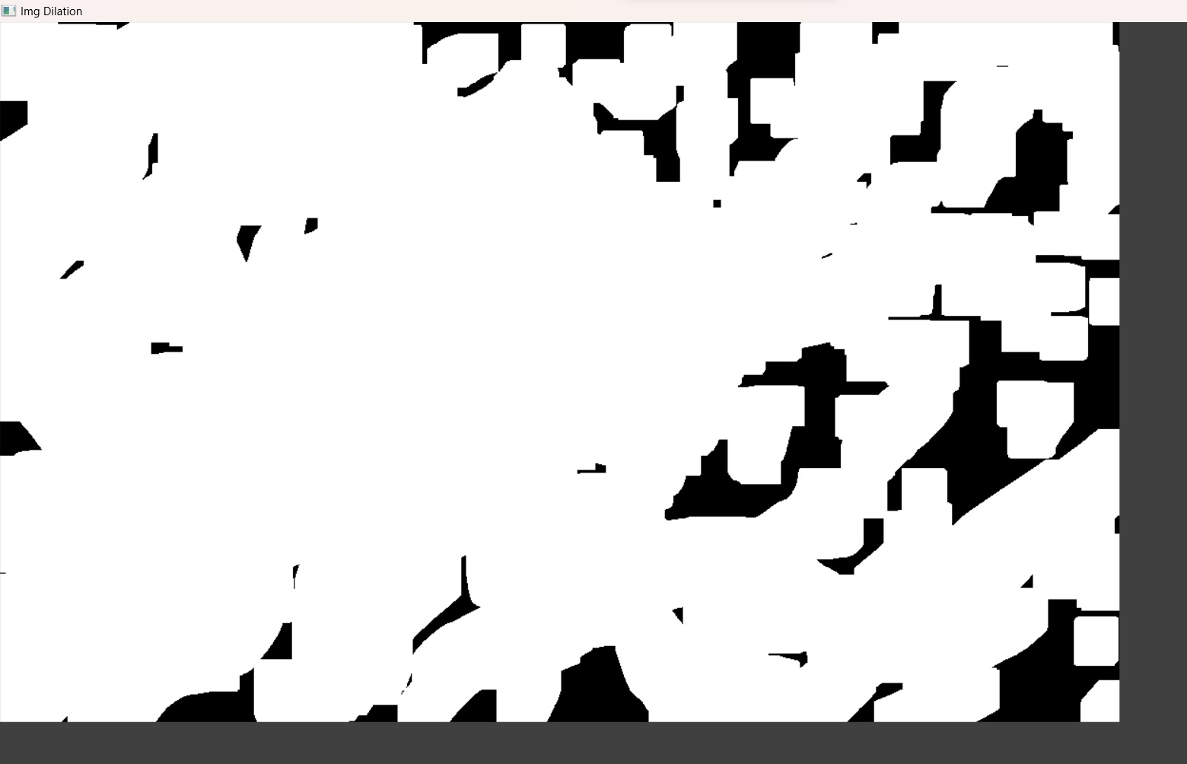

5. import cv2

import numpy as np

kernel = np.ones((5,5),np.uint8)

print(kernel)

path = "C:/Users/justin shawn allen/OneDrive/Pictures/WhatsApp Image 2023-07-10 at 15.15.09.jpg"

img =cv2.imread(path)

imgGray = cv2.cvtColor(img,cv2.COLOR_BGR2GRAY)

imgBlur = cv2.GaussianBlur(imgGray,(7,7),0)

imgCanny = cv2.Canny(imgBlur,100,200)

imgDilation = cv2.dilate(imgCanny,kernel , iterations = 10)

imgEroded = cv2.erode(imgDilation,kernel,iterations=2)

cv2.imshow("Img Erosion",imgEroded)

cv2.waitKey(0)

op:

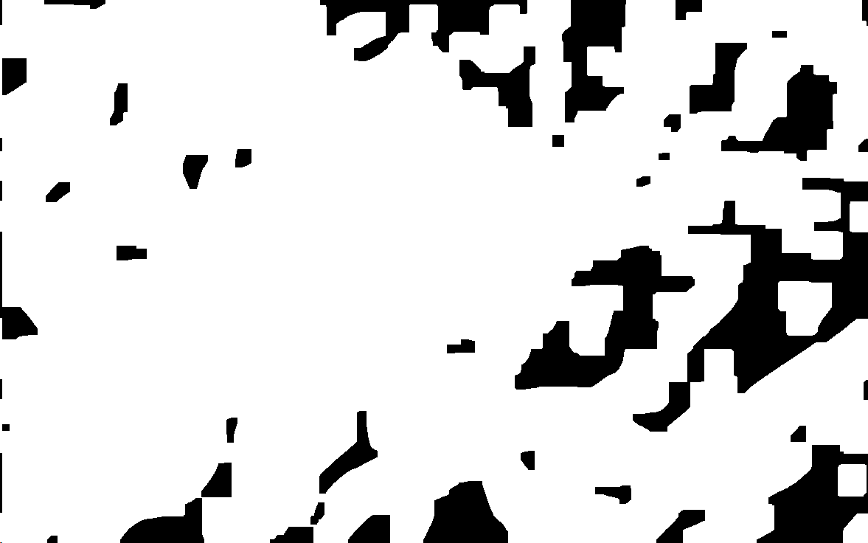

6. import cv2

import numpy as np

cap = cv2.VideoCapture("C:/Users/divya/OneDrive/Documents/COMPUTER VISION/13 REASONS WHY")

if (cap.isOpened()== False):

print("Error opening video file")

while(cap.isOpened()):

ret, frame = cap.read()

if ret == True:

cv2.imshow('Frame', frame)

if cv2.waitKey(250) & 0xFF == ord('q'):

break

else:

break

cap.release() cv2.destroyAllWindows()

OP:

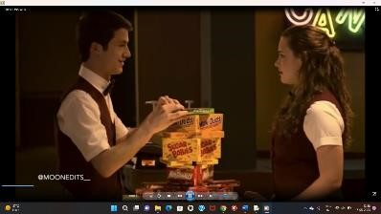

7. import cv2

cap = cv2.VideoCapture(0)

height = int(cap.get(cv2.CAP_PROP_FRAME_HEIGHT))

width = int(cap.get(cv2.CAP_PROP_FRAME_WIDTH))

fps = cap.get(cv2.CAP_PROP_FPS)

path = "0"

fourcc = cv2.VideoWriter_fourcc(*'mp4v')

output = cv2.VideoWriter(path, fourcc, 2,(width, height))

while True:

ret, frame = cap.read()

cv2.imshow("frame", frame)

output.write(frame)

k = cv2.waitKey(24)

if k == ord("q"):

break

cap.release()

output.release()

cv2.destroyAllWindows()

OP:

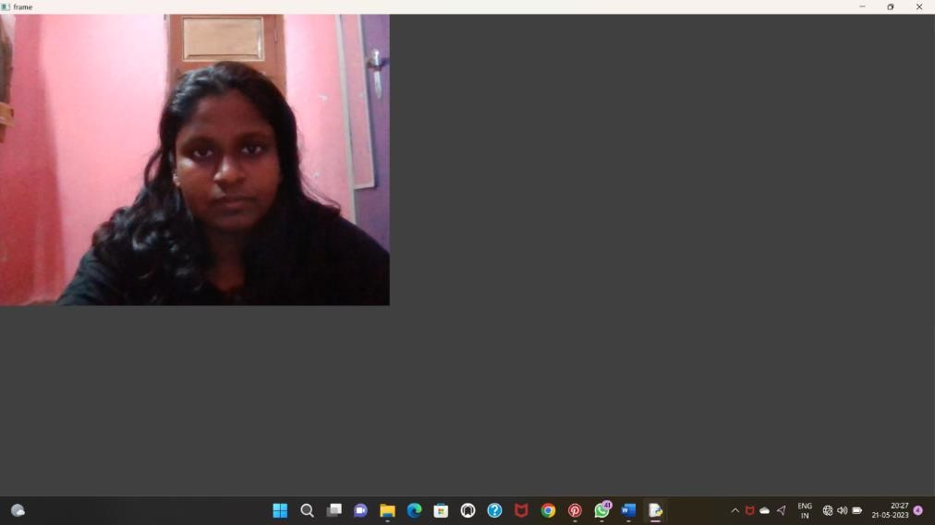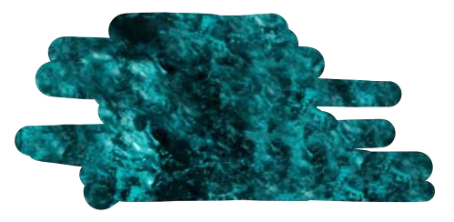

8. import cv2

import numpy as np

kernel = np.ones((5,5),np.uint8)

img = cv2.imread("C:/Users/justin shawn allen/OneDrive/Pictures/WhatsApp Image 2023-07-10 at 15.15.09.jpg" ,cv2.IMREAD_COLOR)

img = cv2.resize(img,(600,600))

cv2.imshow("image",img)

cv2.waitKey(0)

op:

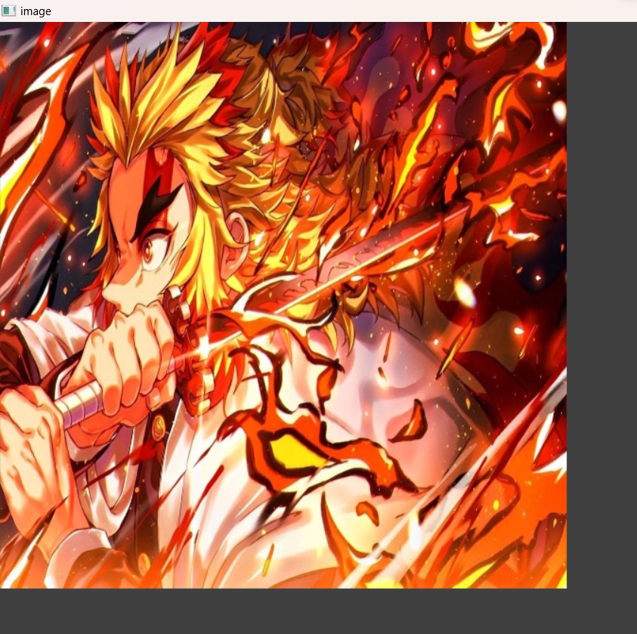

9. import cv2

path = r"C:/Users/justin shawn allen/OneDrive/Pictures/WhatsApp Image 2023-07-10 at 15.15.09.jpg"

src = cv2.imread(path)

window_name = 'Image'

image = cv2.rotate(src, cv2.ROTATE_90_COUNTERCLOCKWISE)

# Displaying the image

cv2.imshow(window_name, image)

cv2.waitKey(0)

op:

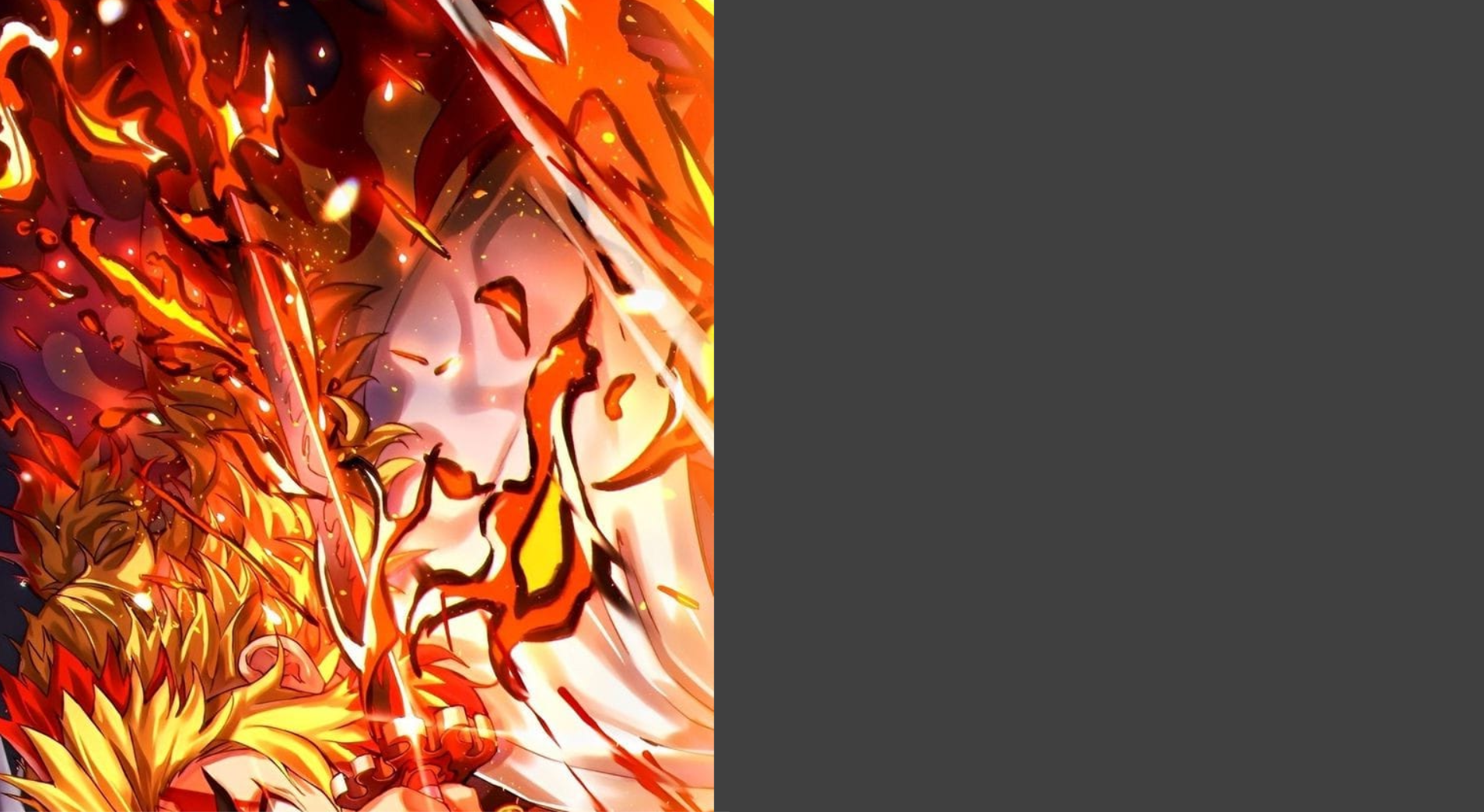

10.

import cv2

path = r"C:/Users/justin shawn allen/OneDrive/Pictures/WhatsApp Image 2023-07-10 at 15.15.09.jpg"

src = cv2.imread(path)

window_name = 'Image'

image = cv2.rotate(src, cv2.ROTATE_90_COUNTERCLOCKWISE)

cv2.imshow(window_name, image)

cv2.waitKey(0)

op: 

11.

import cv2

import numpy as np

# read the input image

img = cv2.imread("**D:/Downloads/bLACK.png**")

# access the image height and width

rows,cols,_ = img.shape

# define at three point on input image

pts1 = np.float32([[50,50],[200,50],[50,200]])

# define three points corresponding location to output image

pts2 = np.float32([[10,100],[200,50],[100,250]])

# get the affine transformation Matrix

M = cv2.getAffineTransform(pts1,pts2)

# apply affine transformation on the input image

dst = cv2.warpAffine(img,M,(cols,rows))

cv2.imshow("Affine Transform", dst)

cv2.waitKey(0)

cv2.destroyAllWindows()

**OUTPUT:**



12

# import required libraries

import cv2

import numpy as np

# read the input image

img = cv2.imread("**D:/Downloads/bLACK.png**")

# find the height and width of image

# width = number of columns, height = number of rows in image array

rows,cols,ch = img.shape

# define four points on input image

pts1 = np.float32([[56,65],[368,52],[28,387],[389,390]])

# define the corresponding four points on output image

pts2 = np.float32([[100,50],[300,0],[0,300],[300,300]])

# get the perspective transform matrix

M = cv2.getPerspectiveTransform(pts1,pts2)

# transform the image using perspective transform matrix

dst = cv2.warpPerspective(img,M,(cols, rows))

# display the transformed image

cv2.imshow('Transformed Image', dst)

cv2.waitKey(0)

cv2.destroyAllWindows()

**OUTPUT:**



13.

import cv2

import numpy as np

cap = cv2.VideoCapture("C:/Users/Welcome/Downloads/pexels-pixabay-855029-1920x1080-

60fps.mp4")

while True:

ret, frame = cap.read()

pts1 = np.float32([[200,300], [5, 2],

[0, 4], [6, 0]])

pts2 = np.float32([[0, 0], [4, 0],

[0, 1], [4, 6]])

matrix = cv2.getPerspectiveTransform(pts1, pts2)

result = cv2.warpPerspective(frame, matrix, (0, 0))

cv2.imshow('frame', frame) # Initial Capture

cv2.imshow('frame1', result) # Transformed Capture

if cv2.waitKey(24) == 27:

break

cap.release()

cv2.destroyAllWindows()

**OUTPUT:**

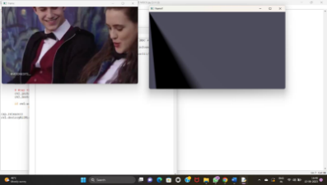

14

import cv2

import numpy as np

# Read source image.

im_src = cv2.imread("**D:/Downloads/bLACK.png**")

# Four corners of the book in source image

pts_src = np.array([[141, 131], [480, 159], [493, 630],[64, 601]])

# Read destination image.

im_dst = cv2.imread("**D:/Downloads/bLACK.png**")

# Four corners of the book in destination image.

pts_dst = np.array([[318, 256],[534, 372],[316, 670],[73, 473]])

# Calculate Homography

h, status = cv2.findHomography(pts_src, pts_dst)

# Warp source image to destination based on homography

im_out = cv2.warpPerspective(im_src, h, (im_dst.shape[1],im_dst.shape[0]))

# Display images

cv2.imshow("Source Image", im_src)

cv2.imshow("Destination Image", im_dst)

cv2.imshow("Warped Source Image", im_out)

cv2.waitKey(0)

OUTPUT:



15

import cv2

import numpy as np

# Load images

img1 = cv2.imread("**D:/Downloads/bLACK.png**")

img2 = cv2.imread("**D:/Downloads/bLACK.png**")

# Define corresponding points

pts1 = np.array([[50, 50], [200, 50], [50, 200], [200, 200]])

pts2 = np.array([[100, 100], [300, 100], [100, 300], [300, 300]])

# Estimate projective transformation matrix using DLT

H, _ = cv2.findHomography(pts1, pts2)

# Apply projective transformation to img1

dst = cv2.warpPerspective(img1, H, (img2.shape[1], img2.shape[0]))

# Display images

cv2.imshow('img1', img1)

cv2.imshow('img2', img2)

cv2.imshow('dst', dst)

cv2.waitKey(0)

cv2.destroyAllWindows()

**OUTPUT:**



16.

import cv2

img = cv2.imread("D:/Downloads/bLACK.png")

cv2.imshow('Original', img)

cv2.waitKey(0)

img_gray = cv2.cvtColor(img, cv2.COLOR_BGR2GRAY)

img_blur = cv2.GaussianBlur(img_gray, (3,3), 0)

edges = cv2.Canny(image=img_blur, threshold1=100, threshold2=200) # Canny Edge Detection

cv2.imshow('Canny Edge Detection', edges)

cv2.waitKey(0)

cv2.destroyAllWindows()

**OUTPUT:**



17.

import cv2

img = cv2.imread("D:/Downloads/bLACK.png")

cv2.imshow('Original', img)

cv2.waitKey(0)

img_gray = cv2.cvtColor(img, cv2.COLOR_BGR2GRAY)

# Blur the image for better edge detection

img_blur = cv2.GaussianBlur(img_gray, (3,3), 0)

sobelx = cv2.Sobel(src=img_blur, ddepth=cv2.CV_64F, dx=1, dy=0, ksize=5) # Sobel Edge Detection on

the X axis

cv2.imshow('Sobel X', sobelx)

cv2.waitKey(0)

**OUTPUT:**



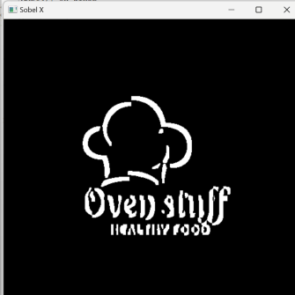

18.

import cv2

# Read the original image

img = cv2.imread("D:/Downloads/bLACK.png")

# Display original image

cv2.imshow('Original', img)

cv2.waitKey(0)

# Convert to graycsale

img_gray = cv2.cvtColor(img, cv2.COLOR_BGR2GRAY)

# Blur the image for better edge detection

img_blur = cv2.GaussianBlur(img_gray, (3,3), 0)

# Sobel Edge Detection

sobely = cv2.Sobel(src=img_blur, ddepth=cv2.CV_64F, dx=0, dy=1, ksize=5) # Sobel Edge

#Detection on the Y axis

# Display Sobel Edge Detection Images

cv2.imshow('Sobel Y', sobely)

cv2.waitKey(0)

OUTPUT:

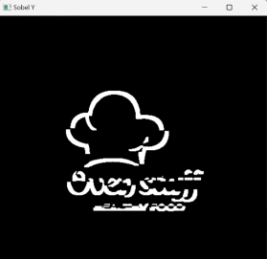

19

import cv2

img = cv2.imread("D:/Downloads/bLACK.png")

# Display original image

cv2.imshow('Original', img)

cv2.waitKey(0)

img_gray = cv2.cvtColor(img, cv2.COLOR_BGR2GRAY)

# Blur the image for better edge detection

img_blur = cv2.GaussianBlur(img_gray, (3,3), 0)

sobelxy = cv2.Sobel(src=img_blur, ddepth=cv2.CV_64F, dx=1, dy=1, ksize=5) # Combined X and Y

Sobel Edge Detection

cv2.imshow('Sobel X Y using Sobel() function', sobelxy)

cv2.waitKey(0)

OUTPUT:

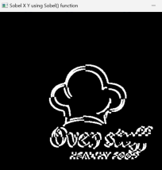

20

import cv2

import numpy as np

img = cv2.imread("D:/Downloads/bLACK.png")

gray = cv2.cvtColor(img, cv2.COLOR_BGR2GRAY)

kernel = np.array([[0,1,0], [1,-8,1], [0,1,0]])

sharpened = cv2.filter2D(gray, -1, kernel)

cv2.imshow('Original', gray)

cv2.imshow('Sharpened', sharpened)

cv2.waitKey(0)

cv2.destroyAllWindows()

OUTPUT:

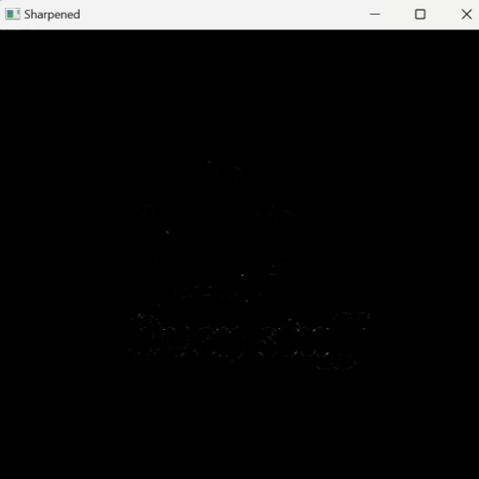

21.

import cv2

import numpy as np

img = cv2.imread("C:/Users/justin shawn allen/OneDrive/Pictures/WhatsApp Image 2023-07-10 at 15.15.09.jpg")

gray = cv2.cvtColor(img, cv2.COLOR_BGR2GRAY)

kernel = np.array([[0,1,0], [1,-4,1], [0,1,0]])

sharpened = cv2.filter2D(gray, -1, kernel)

cv2.imshow('Original', gray)

cv2.imshow('Sharpened', sharpened)

cv2.waitKey(0)

cv2.destroyAllWindows()

Op:

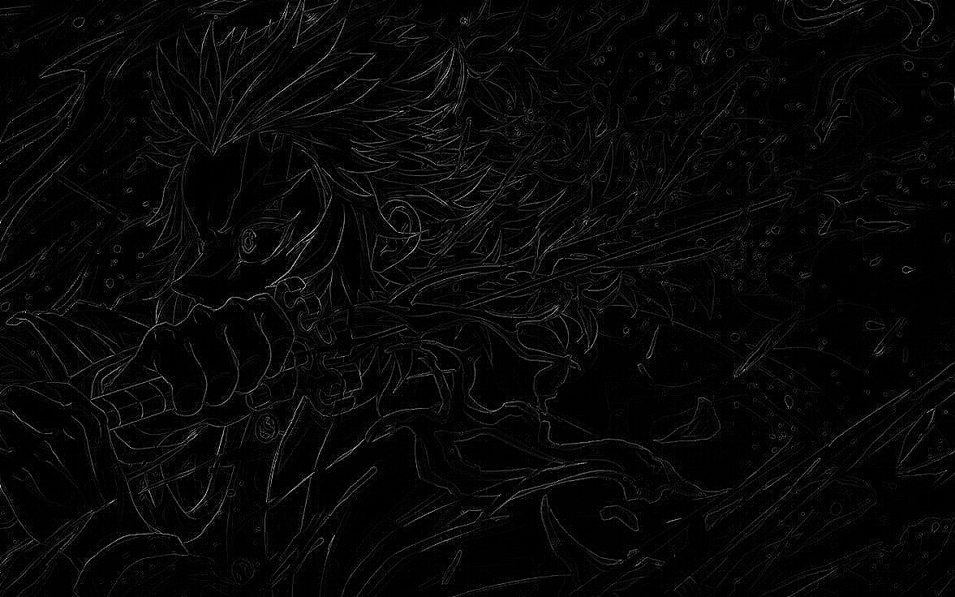

22. import cv2

import numpy as np

img = cv2.imread("C:/Users/justin shawn allen/OneDrive/Pictures/WhatsApp Image 2023-07-10 at 15.15.09.jpg")

img = cv2.resize(img,(255, 255))

gray_img = cv2.cvtColor(img, cv2.COLOR_BGR2GRAY)

# Apply the Laplacian filter with a positive center coefficient laplacian_kernel = np.array([[0, -1, 0], [-1, 5, -1], [0, -1, 0]])

sharpened_img = cv2.filter2D(gray_img, -1, laplacian_kernel)

sharpened_img = cv2.cvtColor(sharpened_img, cv2.COLOR_GRAY2BGR)

cv2.imshow('Original Image', img)

cv2.imshow('Sharpened Image', sharpened_img)

cv2.waitKey(0)

cv2.destroyAllWindows()

op:

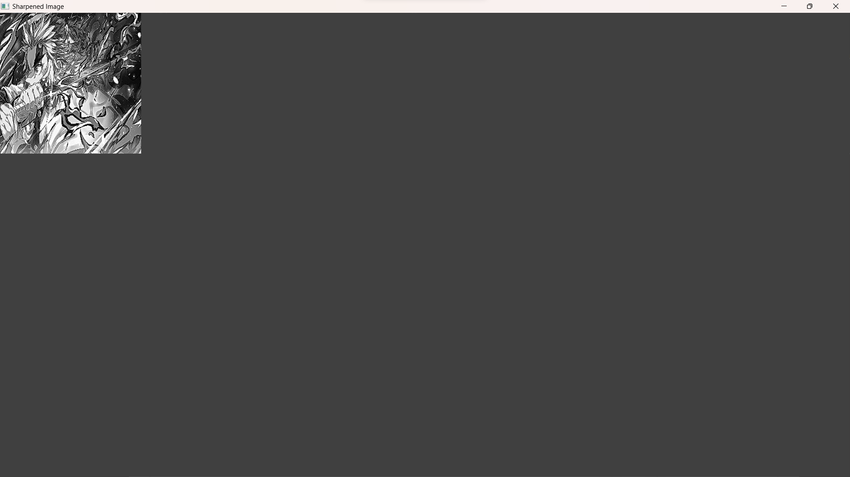

23. import cv2

import numpy as np

img = cv2.imread("C:/Users/justin shawn allen/OneDrive/Pictures/WhatsApp Image 2023-07-10 at 15.15.09.jpg")

gray = cv2.cvtColor(img, cv2.COLOR_BGR2GRAY)

laplacian_kernel = np.array([[0, 1, 0],

[1, -4, 1], [0, 1, 0]])

laplacian = cv2.filter2D(gray, -1, laplacian_kernel)

sharpened = cv2.add(gray, laplacian)

cv2.imshow('Original Image', gray)

cv2.imshow('Sharpened Image', sharpened)

cv2.waitKey(0)

cv2.destroyAllWindows()

Op: 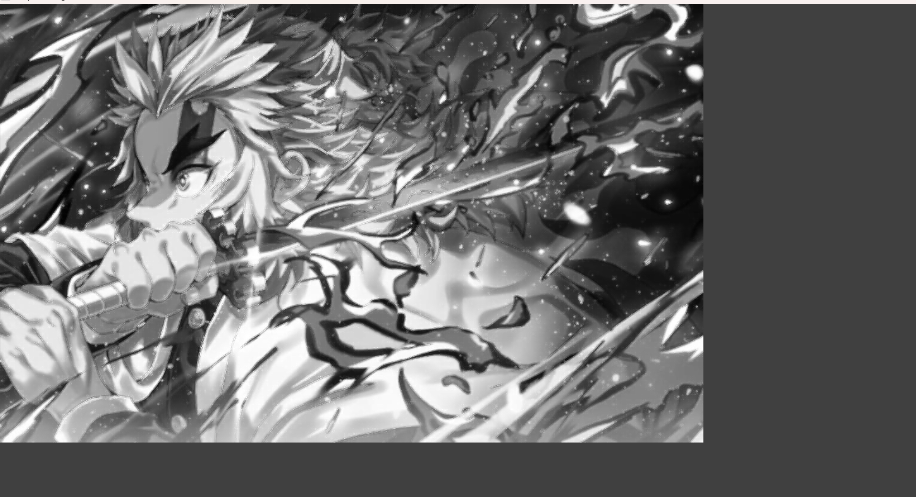

24. h_img, w_img, _ = resized_img.shape

center_y = int(h_img/2)

center_x = int(w_img/2)

h_wm, w_wm, _ = resized_wm.shape

top_y = center_y - int(h_wm/2)

left_x = center_x - int(w_wm/2)

bottom_y = top_y + h_wm

right_x = left_x + w_wm

roi = resized_img[top_y:bottom_y,left_x:right_x]

result = cv2.addWeighted(roi, 1, resized_wm, 0.3, 0)

resized_img[top_y:bottom_y, left_x:right_x] = result

filename = "C:/Users/justin shawn allen/OneDrive/Pictures/WhatsApp Image 2023-07-10 at 15.15.09.jpg"

cv2.imwrite(filename, resized_img)

cv2.imshow("Resized Input Image", resized_img)

cv2.waitKey(0)

cv2.destroyAllWindows()

op:

OUTPUT:

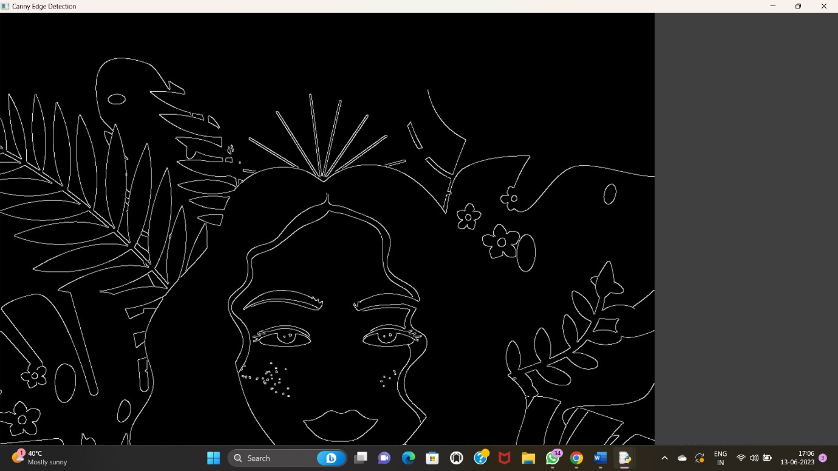

25. a=imread("C:/Users/justin shawn allen/OneDrive/Pictures/WhatsApp Image 2023-07-10 at 15.15.09.jpg");

Lap=[0, 1, 0, 1, -4, 1, 0, 1, 0];

a1=conv2(a,Lap,"C:/Users/justin shawn allen/OneDrive/Pictures/WhatsApp Image 2023-07-10 at 15.15.09.jpg");

a2=uint8(a1); imtool(abs(a-a2),[])

lap=[-1 ,-1, -1, -1, 8, -1, -1, -1 ,-1];

a3=conv2(a,lap,"C:/Users/justin shawn allen/OneDrive/Pictures/WhatsApp Image 2023-07-10 at 15.15.09.jpg");

a4=uint8(a3);

imtool(abs(a+a4),[])

OP:

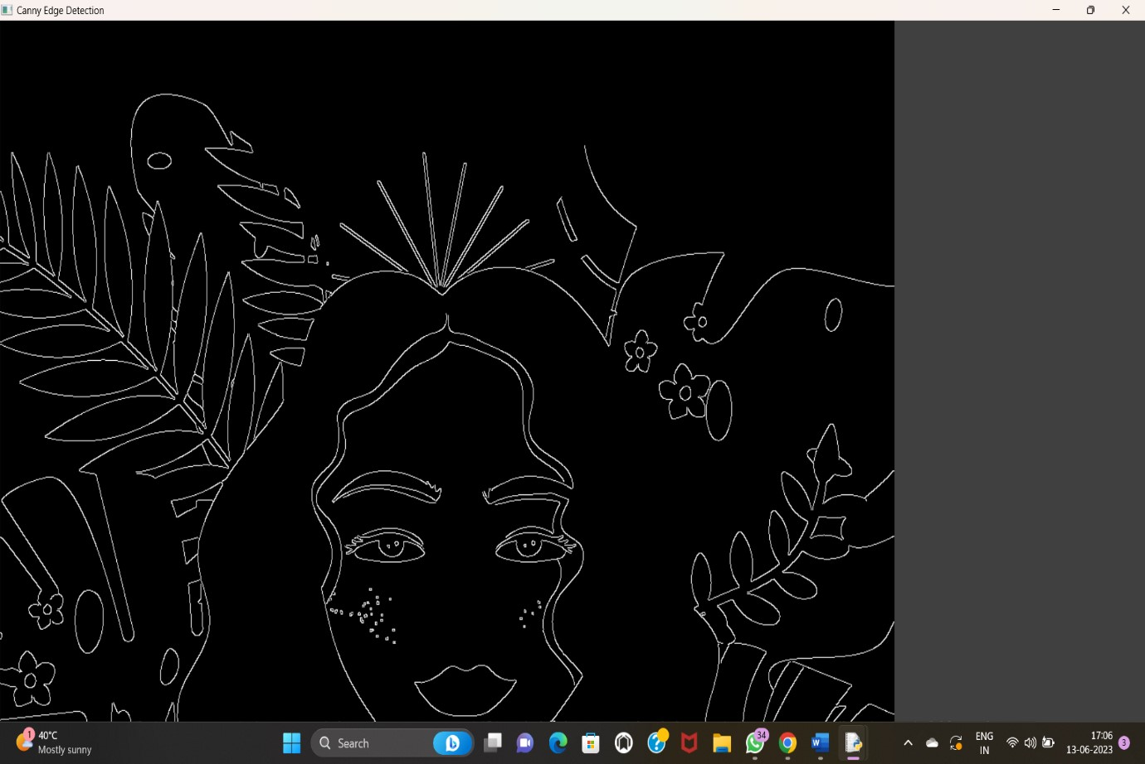

26. import cv2

img = cv2.imread("C:/Users/justin shawn allen/OneDrive/Pictures/WhatsApp Image 2023-07-10 at 15.15.09.jpg")

wm = cv2.imread("C:/Users/justin shawn allen/OneDrive/Pictures/WhatsApp Image 2023-07-10 at 15.15.09.jpg")

h_wm, w_wm = wm.shape[:2]

h_img, w_img = img.shape[:2]

center_x = int(w_img/2)

center_y = int(h_img/2)

top_y = center_y - int(h_wm/2)

left_x = center_x - int(w_wm/2)

bottom_y = top_y + h_wm

right_x = left_x + w_wm

roi = img[top_y:bottom_y, left_x:right_x]

result = cv2.addWeighted(roi, 1, wm, 0.3, 0)

img[top_y:bottom_y, left_x:right_x] = result

cv2.imshow("Watermarked Image", img)

cv2.waitKey(0)

cv2.destroyAllWindows()

Op:

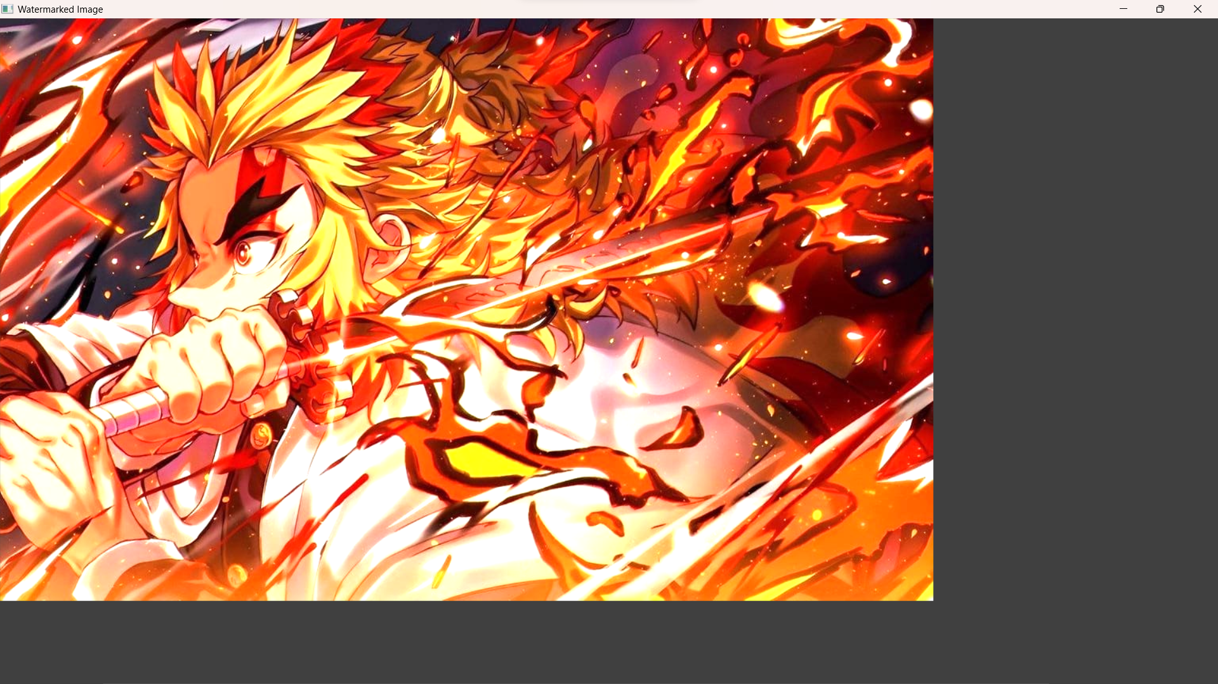

27. import cv2

import numpy as np

image = cv2.imread("C:/Users/justin shawn allen/OneDrive/Pictures/WhatsApp Image 2023-07-10 at 15.15.09.jpg")

img2 = cv2.imread("C:/Users/justin shawn allen/OneDrive/Pictures/WhatsApp Image 2023-07-10 at 15.15.09.jpg")

print(image.shape)

# Print image shape

cv2.imshow("original", image)

imageCopy = image.copy()

cv2.circle(imageCopy, (100, 100), 30, (255, 0, 0), -1)

cv2.imshow('image', image)

cv2.imshow('image copy', imageCopy)

cropped_image = image[80:280, 150:330]

cv2.imshow("cropped", cropped_image)

cv2.imwrite("Cropped Image.jpg", cropped_image)

dst = cv2.addWeighted(image, 0.5, img2, 0.7, 0)

img_arr = np.hstack((image, img2))

cv2.imshow('Input Images',img_arr)

cv2.imshow('Blended Image',dst)

cv2.waitKey(0)

cv2.destroyAllWindows()

Op:

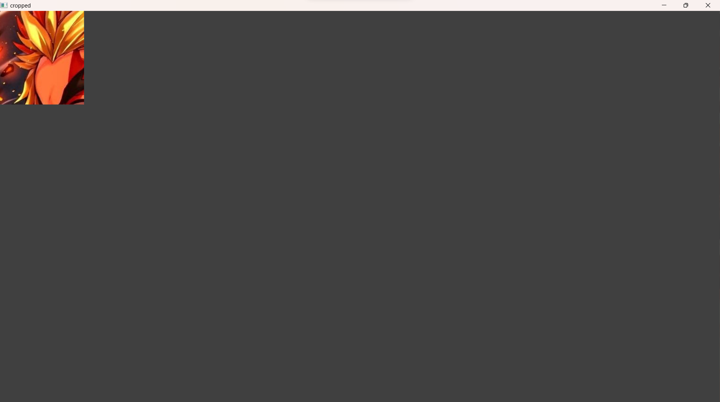

28. import cv2

import numpy as np

img = cv2.imread("C:/Users/justin shawn allen/OneDrive/Pictures/WhatsApp Image 2023-07-10 at 15.15.09.jpg", cv2.IMREAD_GRAYSCALE)

dx = cv2.Sobel(img, cv2.CV_64F, 1, 0)

dy = cv2.Sobel(img, cv2.CV_64F, 0, 1)

edges = cv2.magnitude(dx, dy)

thresh = 100 edges[edges < thresh] = 0

edges[edges >= thresh] = 255

cv2.imshow("Edges", edges)

cv2.waitKey(0)

cv2.destroyAllWindows()

op:

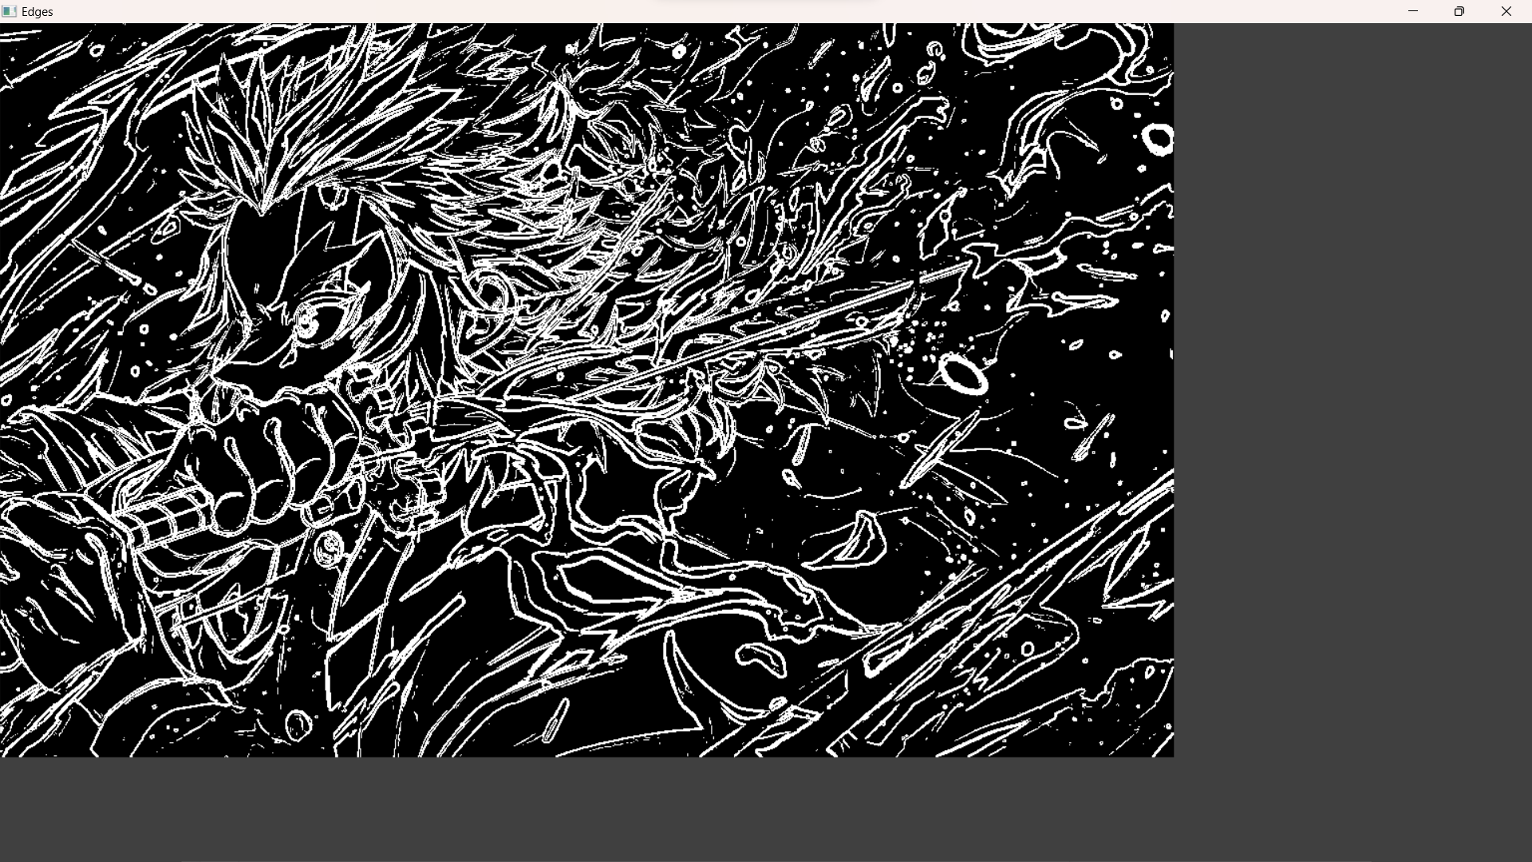

29. import cv2

import numpy as np

img = cv2.imread("C:/Users/justin shawn allen/OneDrive/Pictures/WhatsApp Image 2023-07-10 at 15.15.09.jpg", cv2.IMREAD_GRAYSCALE)

kernel = np.ones((5,5), np.uint8)

erosion = cv2.erode(img, kernel, iterations=1)

cv2.imshow("Original", img)

cv2.imshow("Erosion", erosion)

cv2.waitKey(0)

cv2.destroyAllWindows()

op:

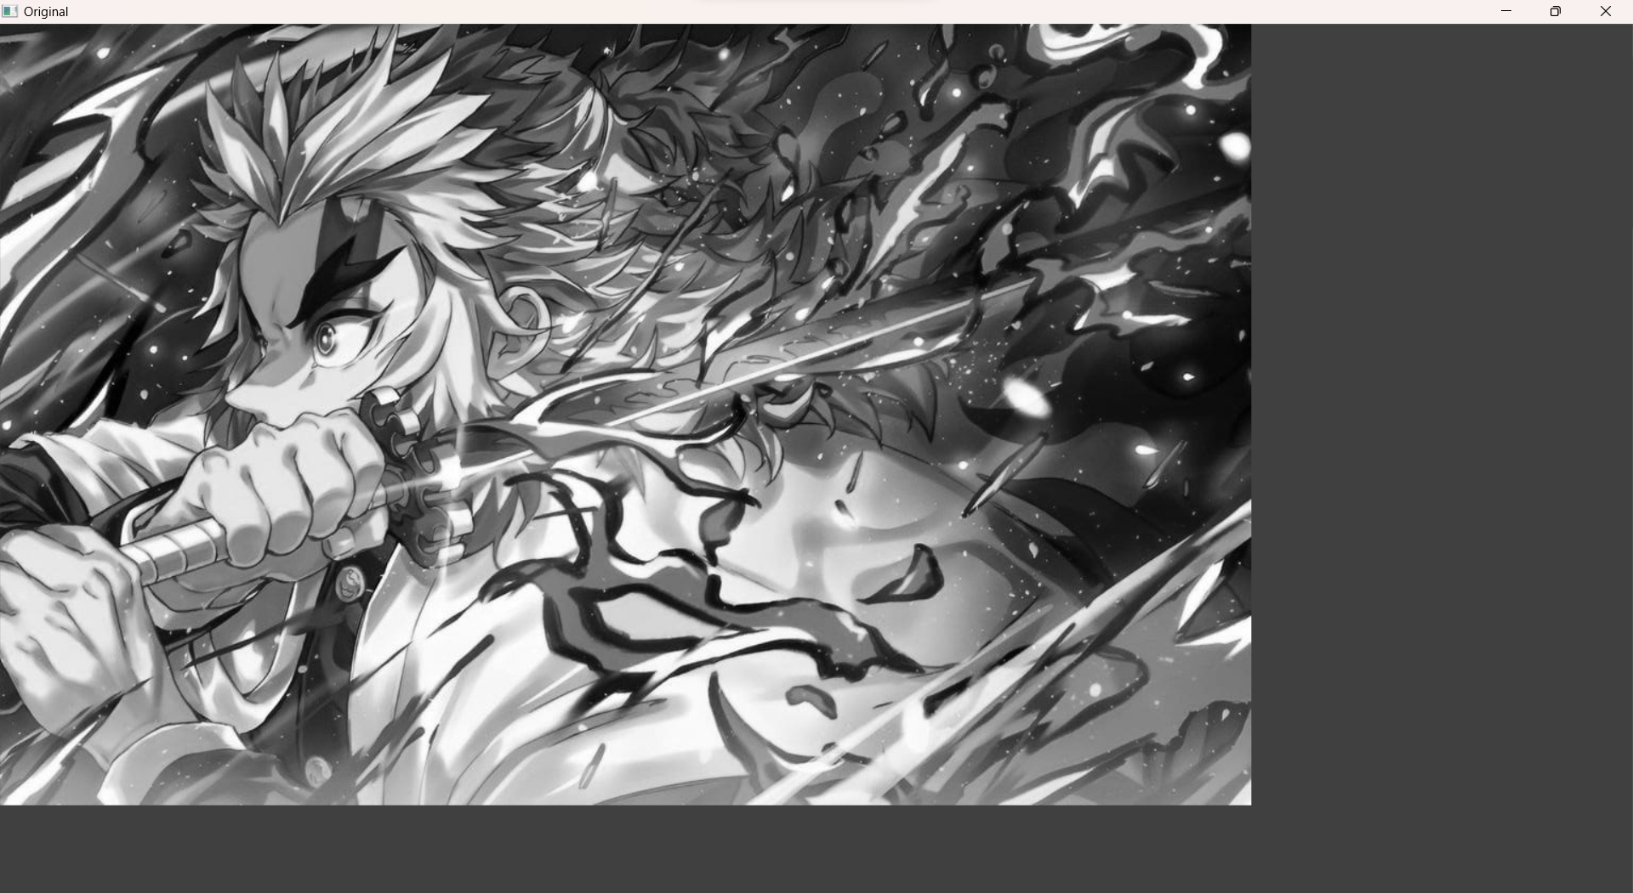

30. import cv2

import numpy as np

img = cv2.imread "C:/Users/justin shawn allen/OneDrive/Pictures/WhatsApp Image 2023-07-10 at 15.15.09.jpg"cv2.IMREAD_GRAYSCALE)

kernel = np.ones((5,5), np.uint8)

dilation = cv2.dilate(img, kernel, iterations=1)

cv2.imshow("Original", img)

cv2.imshow("Dilation", dilation)

cv2.waitKey(0)

cv2.destroyAllWindows()

op: 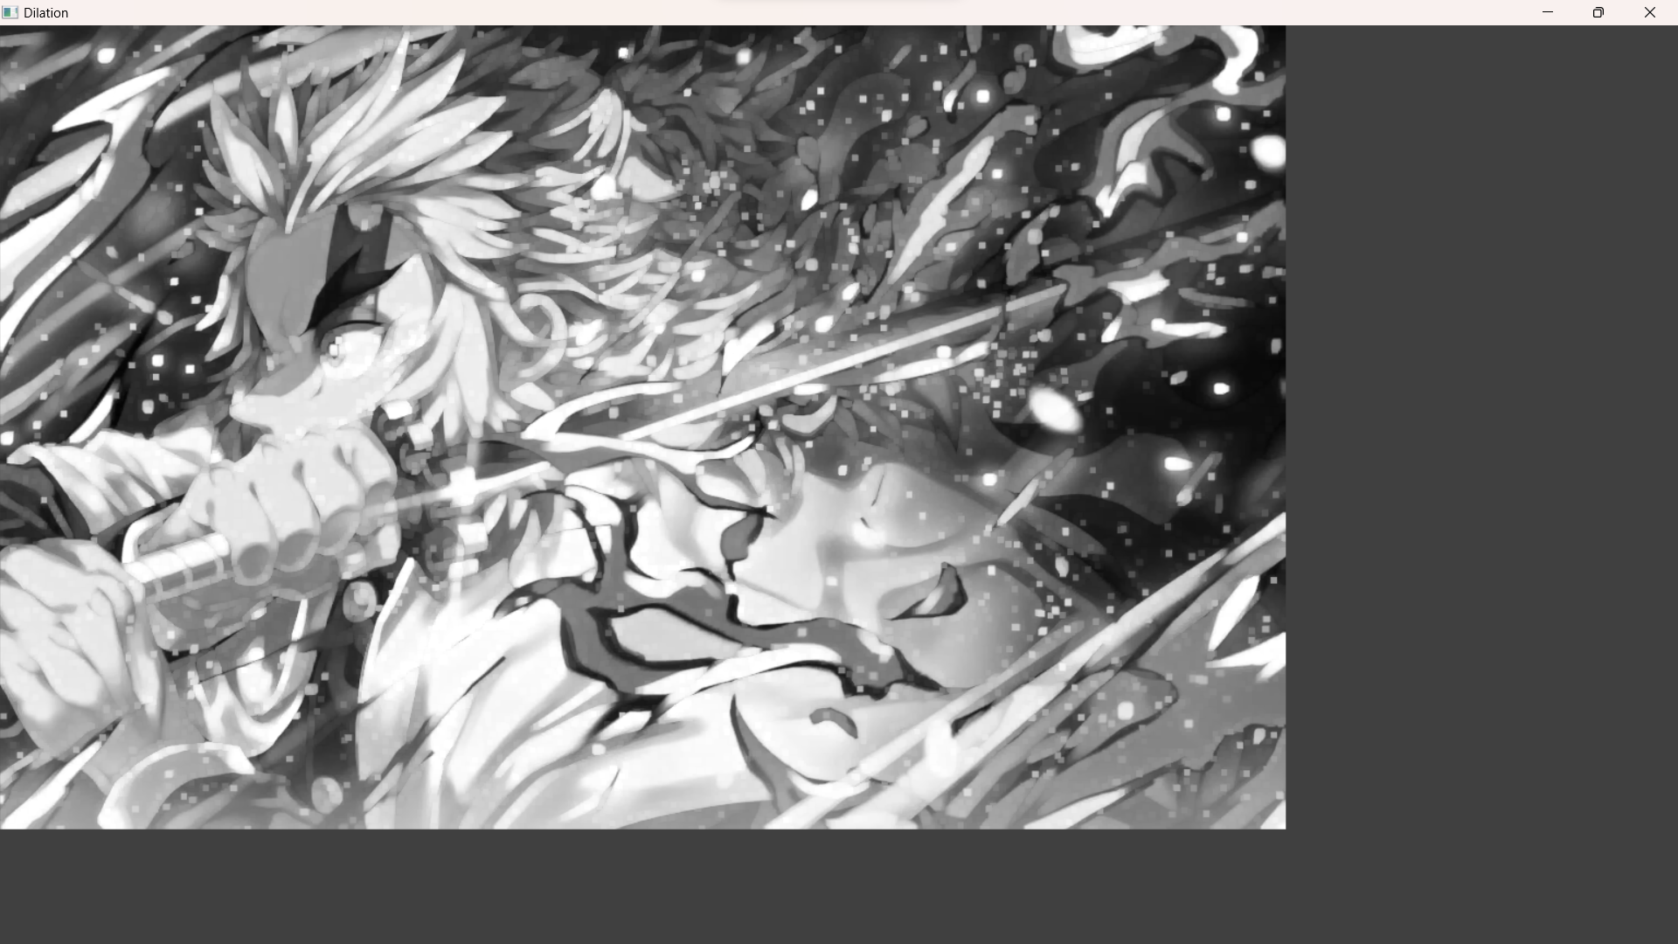

31. Morphological operations based on OpenCV using Opening technique.

Program:

import cv2

import numpy as np

img = cv2.imread("C:/Users/Rakesh/Pictures/air.png", cv2.IMREAD_GRAYSCALE)

kernel = np.ones((5,5), np.uint8)

opening = cv2.morphologyEx(img, cv2.MORPH_OPEN, kernel)

cv2.imshow("Original", img)

cv2.imshow("opening", opening)

cv2.waitKey(0)

cv2.destroyAllWindows()

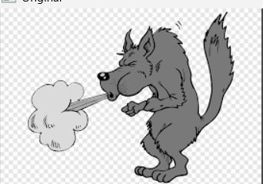

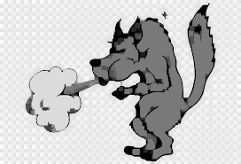

32. Morphological operations based on OpenCV using Closing technique

import cv2

import numpy as np

img = cv2.imread("C:/Users/Rakesh/Pictures/air.png", cv2.IMREAD_GRAYSCALE)

kernel = np.ones((5,5), np.uint8)

closing = cv2.morphologyEx(img, cv2.MORPH_CLOSE, kernel)

cv2.imshow("Original", img)

cv2.imshow("Closing", closing)

cv2.waitKey(0)

cv2.destroyAllWindows()

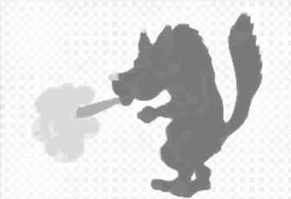

33. Morphological operations based on OpenCV using Morphological Gradient technique

Program:

import cv2

import numpy as np

img = cv2.imread("C:/Users/Rakesh/Pictures/air.png", cv2.IMREAD_GRAYSCALE)

kernel = np.ones((5,5), np.uint8)

grad = cv2.morphologyEx(img, cv2.MORPH_GRADIENT, kernel)

cv2.imshow("Original", img)

cv2.imshow("Gradient", grad)

cv2.waitKey(0)

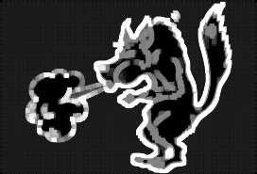

34. Morphological operations based on OpenCV using Top hat technique.

import cv2

import numpy as np

img = cv2.imread("C:/Users/Rakesh/Pictures/air.png", cv2.IMREAD_GRAYSCALE)

kernel = np.ones((5,5), np.uint8)

tophat = cv2.morphologyEx(img, cv2.MORPH_TOPHAT, kernel)

cv2.imshow("Original", img)

cv2.imshow("Top Hat", tophat)

cv2.waitKey(0)

cv2.destroyAllWindows()

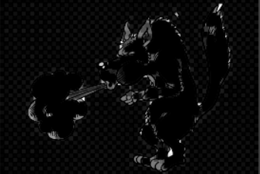

35. Morphological operations based on OpenCV using Black hat technique.

import cv2

import numpy as np

img = cv2.imread("C:/Users/Rakesh/Pictures/air.png", cv2.IMREAD_GRAYSCALE)

kernel = np.ones((5,5), np.uint8)

blackhat = cv2.morphologyEx(img, cv2.MORPH_BLACKHAT, kernel)

cv2.imshow("Original", img)

cv2.imshow("Black Hat", blackhat)

cv2.waitKey()

cv2.destroyAllWindows()

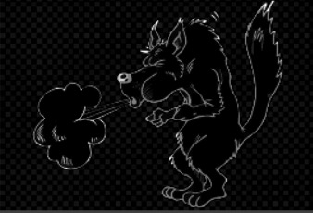

36. Recognise watch from the given image by general Object recognition using OpenCV

import cv2

watch_cascade = cv2.CascadeClassifier("C:/Users/Rakesh/Pictures/air.png", VISION/watch-cascade.xml)

img = cv2.imread("C:/Users/Rakesh/Pictures/10.jpg",VISION/watch.jpg)

gray = cv2.cvtColor(img, cv2.COLOR_BGR2GRAY)

watches = watch_cascade.detectMultiScale(gray, scaleFactor=1.2, minNeighbors=5)

for (x, y, w, h) in watches:

cv2.rectangle(img, (x, y), (x + w, y + h), (0, 255, 0), 2)

cv2.imshow('Watches Detected', img)

cv2.waitKey(0)

cv2.destroyAllWindows()

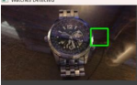

37. Using Opencv play Video in Reverse mode.

import cv2

cap = cv2.VideoCapture("C:/Users/Rakesh/Downloads/mylivewallpapers-com-Neon-Glow-Demon-Slayer.mp4")

total_frames = cap.get(cv2.CAP_PROP_FRAME_COUNT)

current_frame = total_frames - 1

while current_frame >= 0:

cap.set(cv2.CAP_PROP_POS_FRAMES, current_frame)

ret, frame = cap.read()

if not ret:

break

cv2.imshow('Video in Reverse', frame)

if cv2.waitKey(25) & 0xFF == ord('q'):

break

current_frame -= 1

cap.release()

cv2.destroyAllWindows()

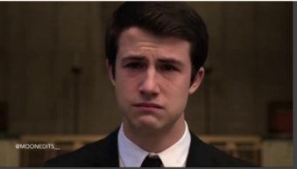

38. Face Detection using Openc

import cv2

img = cv2.imread("C:/Users/Rakesh/Pictures/air.png")

gray = cv2.cvtColor(img, cv2.COLOR_BGR2GRAY)

face_cascade = cv2.CascadeClassifier("C:/Users/Rakesh/Pictures/air.png")

faces = face_cascade.detectMultiScale(gray, scaleFactor=1.1, minNeighbors=5)

for (x, y, w, h) in faces:

cv2.rectangle(img, (x, y), (x + w, y + h), (0, 255, 0), 2)

cv2.imshow('Faces Detected', img)

cv2.waitKey(0)

cv2.destroyAllWindows()

39. Vehicle Detection in a Video frame using OpenCV

import cv2

car_cascade = cv2.CascadeClassifier("C:/Users/OneDrive/Documents/COMPUTER VISION/cars.xml")

cap = cv2.VideoCapture("C:/Users/Rakesh/Pictures/air.png")

while True:

ret, frame = cap.read()

gray = cv2.cvtColor(frame, cv2.COLOR_BGR2GRAY)

cars = car_cascade.detectMultiScale(gray, 1.1, 1)

for (x,y,w,h) in cars:

cv2.rectangle(frame, (x,y), (x+w,y+h), (0,0,255), 2)

cv2.imshow('frame', frame)

if cv2.waitKey(1) & 0xFF == ord('q'):

break

cap.release()

cv2.destroyAllWindows()

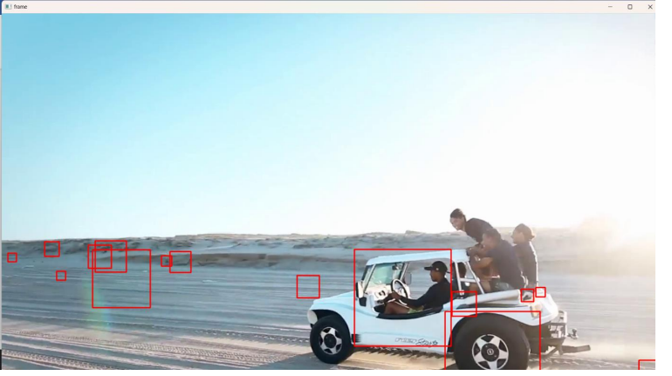

40. Draw Rectangular shape and extract objects

import cv2

img = cv2.imread("C:/Users/Rakesh/Pictures/air.png")

x, y = 100, 100

width, height = 200, 150

roi = img[y:y+height, x:x+width]

cv2.imshow('ROI', roi)

cv2.waitKey(0)

cv2.destroyAllWindows()

